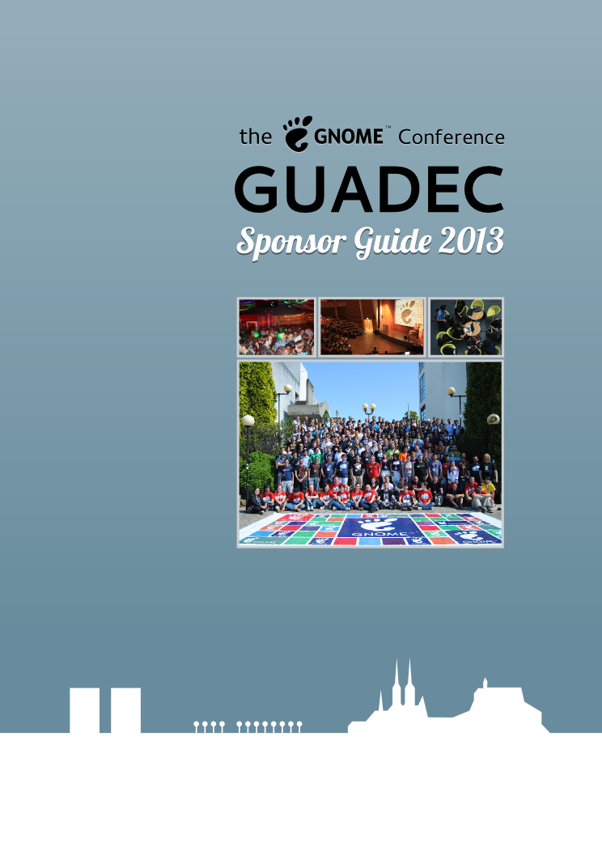

About GNOME

The GNOME Foundation is a US public charity focused on making software that improves
access to technology for all, regardless of geographic location or socio-economic class.

GNOME is an international project that works to create a free, open, easy-to-use computer environment with first-class internationalization and accessibility. Built
entirely from software as approved by the Free Software Foundation, GNOME provides all
of the common tools users expect from a modern computing environment: web browsers, file
managers, multimedia players, e-mail applications, group-ware and games. GNOME
components form the basic desktop environments on many operating systems, e.g., Oracle's
Solaris, Canonical's Ubuntu, Debian, Fedora, Linux Mint and SUSE.

GNOME also provides a flexible and powerful platform for desktop and mobile developers,
and provides an umbrella for an entire ecosystem of related technologies and applications:

- User-facing toolkits, such as GTK+ (widgets and app development framework), Clutter (hardware-accelerated user interfaces), and WebKitGTK+ (browser engine);
- End-user applications, including Shotwell (digital photo manager), Rhythmbox (music management), Ardour (professional audio recording/editing workstation) and Inkscape (vector graphics editor); and
- Support components, including GStreamer (sound, video, and multimedia delivery), D-Bus (interprocess communications), Pango (text layout), GObject (cross-platform C-based object system), and libxml2/libxslt (XML parser and transformations).

Commercial companies also adopt the functionality-rich components of GNOME, as the free
license allows use in software and products at no cost. While useful for companies, GNOME
is the result of collaboration between those companies and volunteers from the public who
focus on creating software that is great and easy to use by everyone. GNOME technologies
have been adopted for consumer and vertical market products, like:

- Amazon Kindle e-book readers (GTK+, WebKitGTK+, Pango);
- TiVo digital video recorders (libxml2, libxslt);
- Nokia Internet tablets (GTK+) and the N900 cell phone (Clutter);
- TouchTunes digital jukeboxes (GTK+, Clutter);
- Garmin GPS navigation devices (GTK+, GStreamer, Pango); and
- TomTom GPS navigation devices (D-Bus, Glib, libxml2).

Besides over a dozen hack-fests per year organized by the GNOME Foundation, other
regular gatherings include the GNOME Boston Summit, a small meeting of core developers;
GNOME.Asia, a rapidly expanding annual event focusing on the growing number of Asian
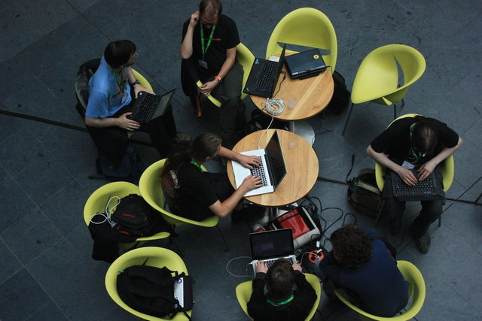
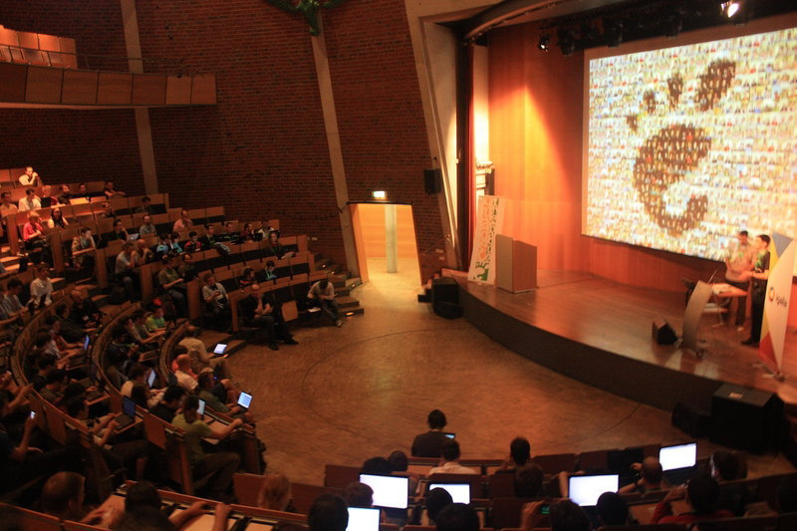
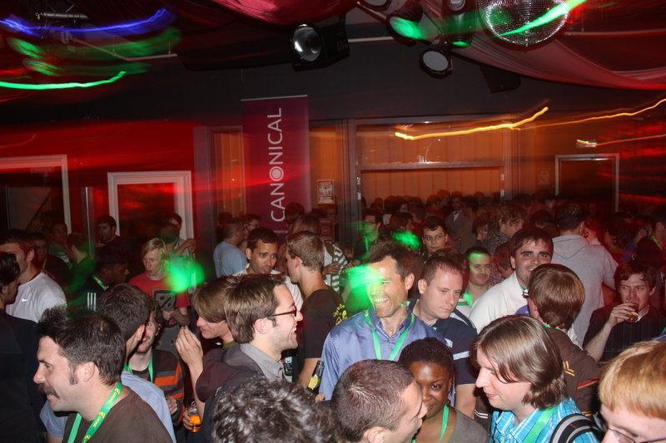
users and developers, and helping push GNOME into new markets, set in 2013 for tech savvy Seoul; and GUADEC, the GNOME Users and Developers European Conference.

About GUADEC

Pronounced GWAH-DECK, GUADEC is the primary congress for GNOME users,
developers, foundation leaders, individuals, governments and businesses worldwide. It
is held annually in cities around Europe, and brings attendees together to share their
experiences and ideas for developing, using and deploying GNOME technologies

GUADEC attracts around 300 key software developers, press, users, businesses and government representatives each year. Presentations are given by leaders, spokespeople,
volunteers and motivated developers on a range of topics including the future directions of the
GNOME Project, Unix, GNU/Linux, Free and Open Source software, development
techniques, cutting edge features and ideas on technology and culture.

The primary aims of the annual GUADEC conference are:

- To set the direction of the GNOME project for the coming year;
- To draw new developers and contributors to the project;
- To help corporate partners be involved in the project;
- To connect developers, corporate partners and governments; and
- To showcase the latest GNOME technologies.

GUADEC is not just a software conference. People come together to meet collaborators
from chat rooms and mailing lists, to network, to visit old friends and make new ones, and
most of all to have fun! The venue and program for GUADEC 2013 will reflect these important
aspects and will include time for tourism, sports and experiencing local traditions.

GUADEC 2013

GUADEC 2013 will be hosted in Brno which is the second largest city of the Czech Republic and capital of the region of Moravia. Lying in the south of the Czech Republic, it a short distance from other major cities of the area like Vienna and Bratislava. This city of about 400,000 people is a bustling university town and home to major offices of a range of of technology companies such as IBM, Motorola, Honeywell and Red Hat.

GUADEC 2013 will be held in early August when there is usually excellent weather in Brno, with sunny summer days and average temperatures around 22º C, perfect for sightseeing, socializing
and hacking. Brno University of Technology will provide the premises for the conference, offering an academic environment, technical concentration, and access to the city's sights.

The most important sights of the city include the castle and fortress Špilberk and the Cathedral of Saints Peter and Paul on Petrov hill, these two formerly medieval buildings form the characteristic cityscape and are often depicted as its traditional symbols. The other large preserved castle in the city is Veveří Castle near the Brno Dam Lake, this castle is a subject for a couple of legends like a number of other places in Brno. Another important monument of Brno is the Villa Tugendhat, a dramatic example of Modern Architecture which has been included in the UNESCO list of World Heritage Sites. Brno is surrounded by pleasant nature, one of the especially attractive areas nearby being the Moravian Karst with its roughly 1100 cavern and gorges and its extensive nature preserve.

Become a sponsor

GUADEC sponsorship offers a wide variety of benefits, and encourages sponsors to become
more deeply involved in the community. In addition to the below benefits, returning
sponsors are eligible for a 6% or 10% package discount. The opportunity also exists to
combine sponsorship of both GUADEC and GNOME.Asia events at a reduced price.
Please see the Sponsor Package section and Terms and Conditions for more details.

- Meet key contributors. It's a unique opportunity to meet contributors, maintainers
and users of one of the world's leading Free and Open Source technology platforms.
- Influence future product direction. Sponsoring and attending GUADEC not only gives you advance information on the GNOME's plans for the coming year, but provides you a voice in shaping those plans.
- Access technical talent. Experienced and capable software developers from around the globe attend GUADEC. Sponsorship allows you to meet individuals, consultancies, and potential business partners who can help you achieve your technical goals.
- Network with technology decision-makers and influencers. GUADEC attendees typically include individuals who are responsible for government purchasing, setting technical agendas at major corporations, determining academic work and research.
- Encourage technology adoption. GUADEC has been a site for product launches, and can be a great place to encourage software developers to use new technologies.
- Promote your company. Sponsorship provides you with promotion through visible advertising, technical presentations, and international press coverage.
- Contribute to the development of GNOME technologies. Supporting GUADEC helps support the development of new features and components, as the event hosts planning and coding sessions, as well as technology and interoperability meetings.
- Give back to free and open source software. You will be recognized not only as a sponsor of GUADEC, but also a supporter of free software, the GNOME project, and the ideals on which these are founded.

Past sponsors who help make GUADEC and continuing GNOME work possible include:

ACCESS
Igalia
Novell
SUSE
ARM
Intel
O'Reilly
Canonical/Ubuntu
Lanedo Openismus
Collabora
Linux Magazine
OpenShine
Fluendo
Mandriva
Red Hat
Google
Meego
Sun Microsystems
Hewlett-Packard
Mozilla
The Linux Foundation
IBM
Nokia
Ubuntu User

Sponsorship Packages

GUADEC 2013 | Platinum  €15,000  or  $20,000 | Gold  € 10,000  or  $13,000 | Silver  € 5000  or  $6,500 | Bronze  € 1000  or  $1300
Table in the exhibit space [1]
Your banner in the reception area
Your banner in two conference rooms
Company logo on conference name badge front
Company logo inside badge beside the schedule
Company logo on front page of GUADEC webpage
Logo and short company description (max. 100
words) on event webpage “Our sponsors”
Professional pass vouchers for networking event [2] | 25 | 8 | 5 | 3
[1] Due to space constraints bronze level sponsors may be included in the same table.
[2] Also available instead are percentage discounts for all of a Sponsor's employees.

Also consider sponsoring the 2013 .Asia Summit: See details @ http://2013.gnome.asia/sponsorship

GNOME.Asia  (USD $) | Platinum  $ 12,000 | Gold  $ 9,000 | Silver  $ 5,200 | Bronze  $ 2,600
Equivalent in Euros (€) | ~ € 9,175 | ~ € 6,880 | ~ € 3,975 | ~ € 1,990
Sponsor both GUADEC and GNOME.Asia -  Additional cost on your GUADEC package | + € 6,000  or  $ 7,800 | + € 4,500  or  $ 5,800 | + € 3,000  or  $ 3,800 | + € 1,500  or  2,000
Combined sponsorship packages will save you: | € 3,175 | € 2,380 | € 975 | € 490

Extra GUADEC opportunities: These can be part of a package or can be negotiated separately.

Sponsor of official conference reception
(at own cost)
Sponsor a party
(at own cost)
Coffee break sponsor
Sponsor presentation slot
(3 minute lightning talk)
Logo or advertisement displayed on partnering websites

Media partners: On-line and paper media publishers are welcomed to become partners through news, direction of participants to conference registration and/or conference reporting. Partners will be credited as sponsors on the web and in the conference program. Papers or magazines may be distributed to attendees.

Custom Packages: If you find that none of the listed sponsorship packages fits your organization's needs or budget it is always possible to put together a customized package. If you would like more information or to discuss sponsorship opportunities, please contact: sponsors@guadec.org

Terms and Conditions

- By submitting a completed sponsor application form, all sponsoring entities ("the sponsor") agree to these Terms and Conditions for GUADEC ("the conference").
- Sponsorship applications are handled on a “first come-first served” basis. Sponsors should be committed to Free Software deployment and improvement, and supportive of the conference organizers' mission. The conference retains the right to reject sponsors that it deems inappropriate.
- Sponsorship pledges cannot be processed without payment. All pledges must be in Euros (€) or US Dollars ($), or with respect to GNOME.Asia South Korea Won (₩), or other currency as agreed, and made payable to the organization designated by the GNOME Foundation. The sponsor will be contacted regarding details of the money transfer.
- GNOME.Asia packages are subject to separate Terms and Conditions. For more details see: http://2013.gnome.asia/sponsorship
- After written acceptance of the sponsor's application form by the conference, the sponsor must provide any further signed agreements and the sponsorship funds to the conference organizers within 30 days of receiving the conference sponsorship invoice.
- Once the sponsor's application has been secured, the sponsor must provide logos, digital graphics and/or any other details as required (e.g., the sponsor's brand name, trademarks, etc) within 14 days. The sponsor grants to the conference the right and permission to use its name and/or logo for promotion of the event. Likewise the sponsor is granted the right and permission to use the conference name and/or logo for communications about the event.
- Requested materials should reach the conference organizers by requested deadlines, or they may not be properly processed. Physical materials (banners, handouts, etc) should be provided by the sponsor at least 30 days in advance of the event.
- For sponsorship packages that include the use of signage, please note that space may be limited. The conference will inform each sponsor of the maximum size or number of signs allowed. The conference will not be liable for damage or loss of sponsors’ properties by fire, theft, accident or any other cause, by negligence or otherwise or in case of force majeure.
- The sponsor may not sublet, assign or apportion any part of the item(s) sponsored nor represent, advertise or distribute literature or materials for the products or services of any other firm or organization except as approved in writing by the conference.
- To limit conference production costs, the conference organizers may limit the number of colors used to print sponsor logos and materials.
- To minimize detritus, the conference may use electronic versions of inserts and advertisements. The sponsors will be notified in advance to be able to provide material that might be better suited to the medium used.
- Repeat sponsor status and discount level will be determined by the the conference organizers. Eligible sponsors may claim only one discount. Repeat sponsors' discounts: a) 6% package discount is available to those organizations sponsoring at any level who have also sponsored the conference within the past 2 years, i.e., 2011 or 2012. b) A 10% discount is available for organizations who qualify for 6%, but who will this year increase their sponsorship package level, e.g., Silver in 2012 to Gold in 2013.
- Any remaining funds from sponsorship money will be donated to the GNOME Foundation upon completion of the conference for the GNOME Foundation's general use.
- Sponsorship is not limited to financial support but can also be in the form of material provisions, e.g., hardware, software, services, etc. Should your organization be interested in sponsoring in an arrangement not listed in this brochure, please feel free to contact the conference organizers to discuss your preferences: sponsors@guadec.org

Sponsorship Application Form

GUADEC 2013: August 1st to 8th, Brno, Czech Republic

Please review the terms and conditions of sponsorship listed above before completingand submitting this form. To ensure that matters move quickly and smoothly, electronic
documents and transactions are used where possible. Unless requested otherwise, the
invoice and other documents will be sent as printable PDF files. If required by law, you must
provide paper documents with proper signatures and/or stamps.

Combine GUADEC+GNOME.Asia packages:
[ ] Platinum € 15,000/$ 20,000 [ ] + € 6,000/$ 7,800 for GNOME.Asia Platinum-level
[ ] Gold € 10,000/$ 13,000 [ ] + € 4,500/$ 5,800 for GNOME.Asia Gold-level
[ ] Silver € 5,000/$ 6,500 [ ] + € 3,000 /$ 3,800for GNOME.Asia Silver-level
[ ] Bronze € 5,000/$ 1,300 [ ] + € 1,500/$ 2,000 for GNOME.Asia Bronze-level

[ ] Custom package (as agreed) ________________________________________

Repeat Sponsor Discount:

Event previously sponsored: _________________ [ ] 6% Package Discount
Increased 2013 sponsorship level? [ Yes / No ] [ ] 10% Package Discount
Extras: ________________________________________________________________
GUADEC level (+ GNOME.Asia or extras) (-discount) = Total Amount: _______________
Details (as agreed): ______________________________________________________
Invoicing Details: ________________________________________________________
Company Name: ________________________________________________________
Contact Person: ________________________________________________________
Full Title / Position: ______________________________________________________
Email: _____________________________ Phone: __________________________
Company Address: ______________________________________________________
City: ________________________________ Postal Code: ______________________

Authorized Signature: __________________________________ Date: ____________

Please mail this form by post to: GNOME Foundation

PO Box 101, Groton, MA 01450, USA
Or email a scan of this form to: sponsors@guadec.org

