1. How to get to Beihang from Capital airport by Public Transportation.
1) Take Airport Express to 三元桥(Sanyuanqiao), works from 6:00 to 23:00, 25¥
2) Take Subway Line 10 to 西土城(Xitucheng), works from 5:00 to 23:00, 2¥
3) Walk out from Exit A or Exit B, go straight to the north about 700 meters, you'll see 北京航空航天大学(BUAA, Beihang University)
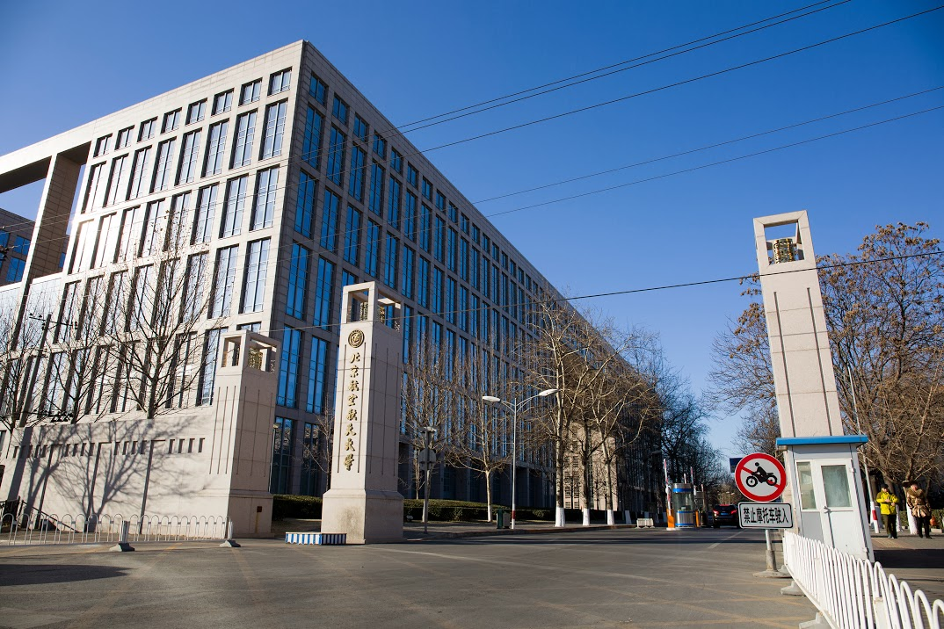
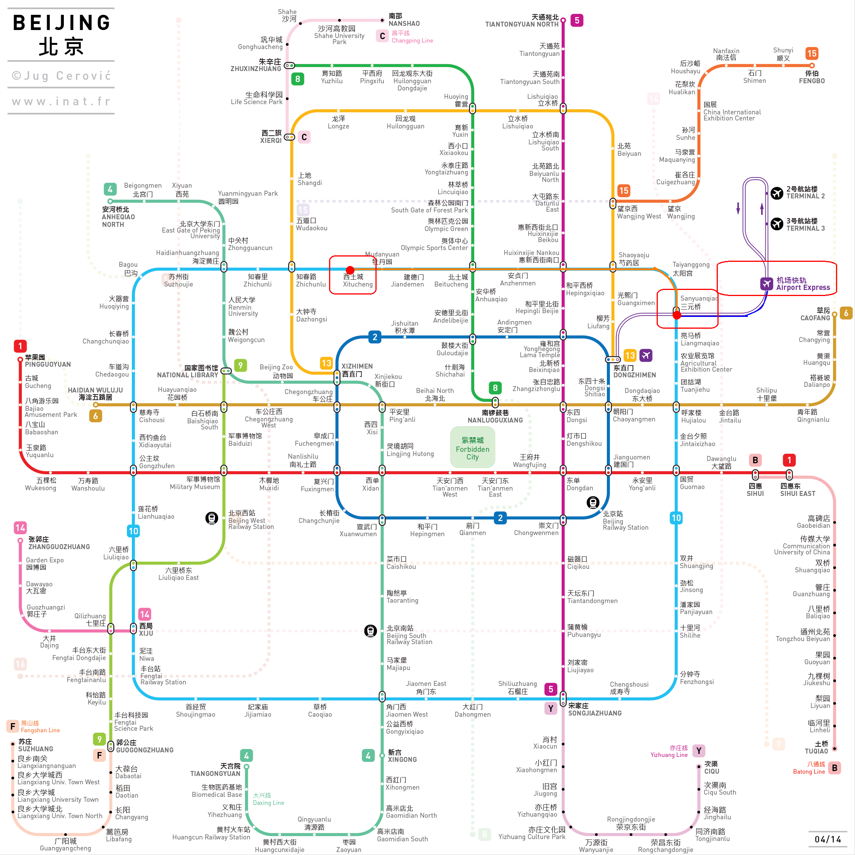

New Main Building of Beihang University
(北京航空航天大学新主楼会议中心)

2. How to get to Beihang from Capital airport by taxi.
Show the below word to taxi driver, the price in night might be higher than normal, not more than 150¥.
请带我到 北京航空航天大学东门(学知桥北) 新主楼会议中心,多谢!

3. How to get to Beihang Training Center Hotel.
Beihang Training Center Hotel (北航培训中心宾馆), Red A flag is the Hotel.

4. How to transfer between New Main Building and Hotel.
Just follow below map, I've added the keyword in it.

5. How to get to Basket Ball and Foot Ball ground.
Just follow below map, I've added the keyword in it.
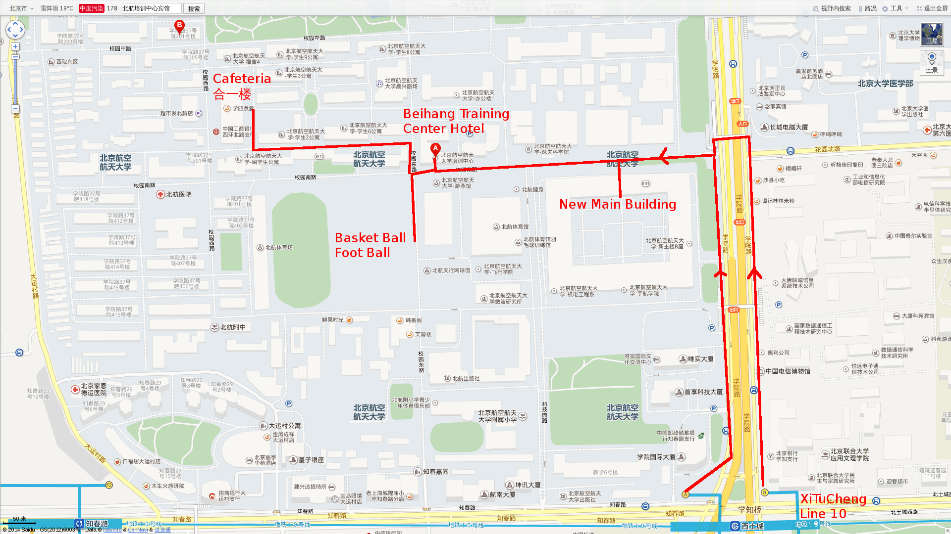
6. Contacts
If any emergent issue, please contact Emily Chen (+86 13522064520).
Alarm 110
Ambulance 120

