

Proposal of GNOME.Asia Summit 2014

/ GNOME Conference & Hackfest

Proposed city: BeiJing
Proposal by: BeiJing GNOME User Group (BJGUG)
Proposed date: Aug 30 - Aug 31 in 2013
Contact person: BinLi <binli@gnome.org> & Born <linuxbqj@gmail.com>

Table of Contents
1. Introduction 3
2. Local Organizers and Supporters 4
BJGUG (www.bjgug.org) 4
Software Freedom Day(SFD) 5
Ubuntu 13.04 Release Party 6
OpenStack Salon 7
GNOME Lauch Party 8
Key Event List 9
Proposed organizing committee 10
Proposed supporting organisations 10
3. Objectives 11
4. Venue & date 12
Tentative dates 12
Suggested Venue 13
College Software of BeiHang University 13
University of Chinese Academy of Sciences 15
QingHua University 16
5. Target audiences 17
6. Activities and schedule 18
Hackfest 18
Public Conference 18
Party / Sports 18
Optional: 1 day local tour 18
7. Expectation and marketing 19
Hackfest 19
Conference 19
8. Budget Estimation 20
Maximum Budget 20
Minimum Budget 21
9. Potential sponsors & media partners 22
10. Conclusion 23

1. Introduction
The BJGUG team proposed to the GNOME.Asia Committee and The GNOME Foundation that the upcoming GNOME.Asia Summit 2014 / GNOME Hackfest to be hosted in Beijing.
Beijing is is the capital of the People's Republic of China, has been the political and cultural center of China for centuries. The city is renowned for its opulent palaces, temples, and huge stone walls and gates, and its art treasures and universities have made it a center of culture and art in China. There are good airport connections, train/bus infrastructure and subway infrastructure.
In China there are a lot of GNOME hackers, espicially in Beijing, which are from SUSE, Redhat, Canonical, Oracle, Intel, etc.
The tentative dates of the event will be around the GNOME 3.9/3.10 release and at the weekend.
It's easy to get VISA for foreign participants / speakers, some countries in Asia, such as Japan and Singapore have a 15days visa-free period for travel within Beijing. We strongly believe Beijing is the best place to host this upcoming conference and hackfest.

2. Local Organizers and Supporters

BJGUG (www.bjgug.org)
BJGUG - BeiJing GNOME User Group, is a not for profit opensource organisation based in BeiJing. BJGUG was established in 2008 and aimed to spread GNOME for users, developers and translaters in Beijing and China.
In 2009 we designed our logo, looks like a butterfly, which is mean BJGUG and GNOME could break the cacoon into a butterfly, spreading and developing quickly in Beijing and China.


BJGUG have regular meeting/event every month, here we'll show some big events, and also there are an event list for all our key events.
A lot of members from BJGUG participated the GNOME.Asia 2013 in Korea and GNOME.Asia 2012 in HongKong as speakers and volunteers. And also we also had a lot of members to particpate each GNOME.Asia in different places.
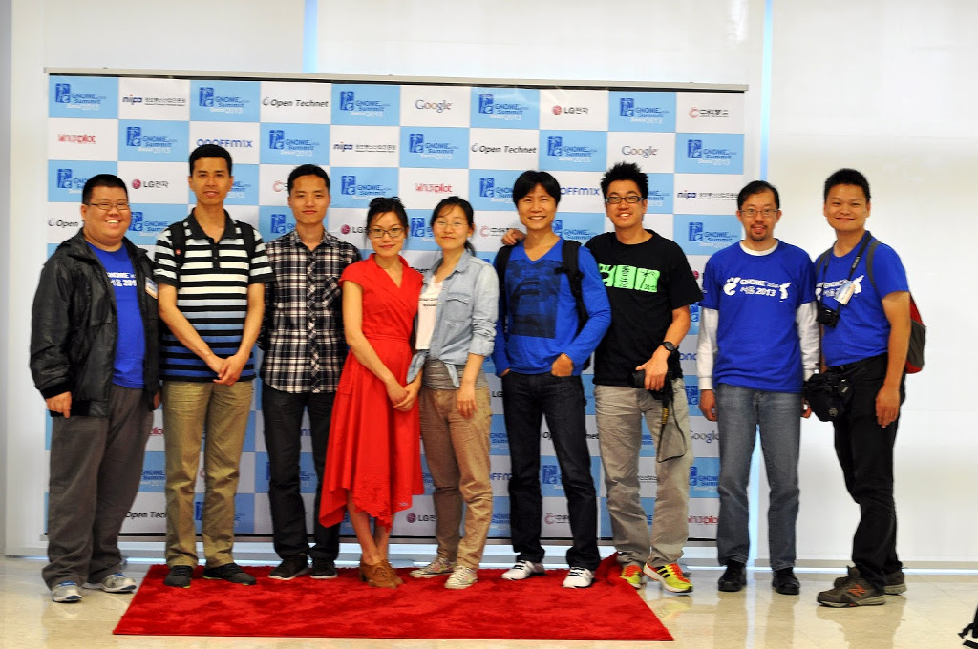
In Korea, six speakers from Beijing took part in the GNOME.Asia 2013 Summit.

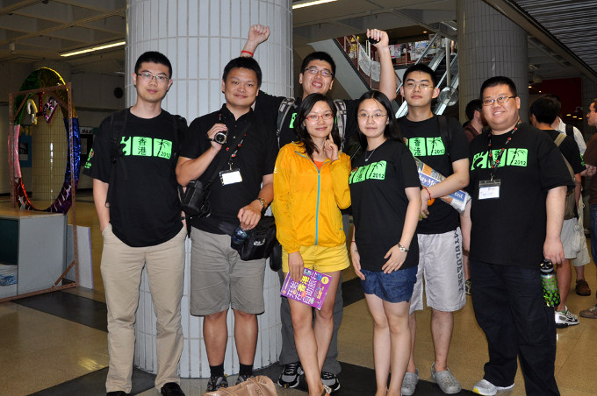
In HongKong, also six speakers participated.

Software Freedom Day(SFD)
Software Freedom Day(SFD) is a big festival for BJGUG. From 2009 we had organised four times events for celebrating SFD, each time there are more than 50 audiences. We cooperated with the University and local opensource community to organise this festival.
And this year we are still scheduling now. :)
This picture is from SFD2012 which was hold on Sept.15 2012.

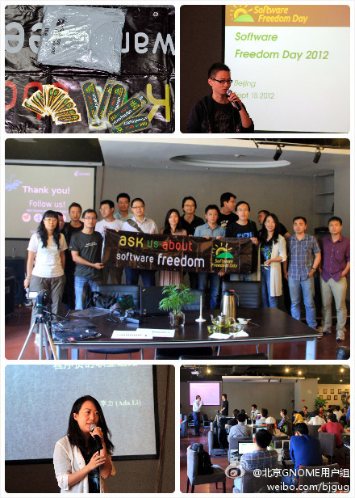

Ubuntu 13.04 Release Party

Ubuntu 13.04 release party is a big event in 2013. More than 200 paticipants took part in.

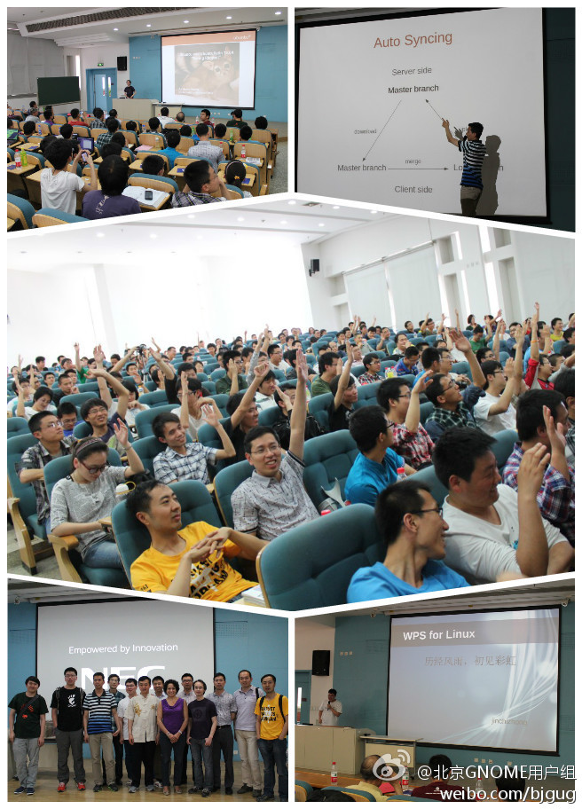

OpenStack Salon
Here is another big events in 2012!
BJGUG organised opensource computing and OpenStack Salon on May 19th, 2012. We jointed ChinaUnix community and got sponsor from it for the venue. There are about 200 people here to participated this meeting.
http://www.it168.com/itclub/openstack/content.html
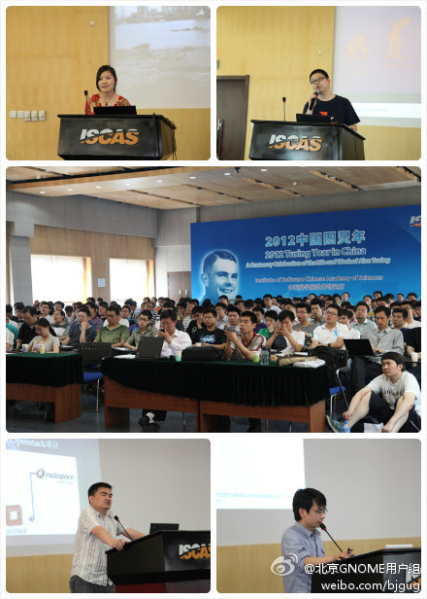

GNOME Lauch Party
Each big release of GNOME, we organized the Lauch Party for it, to spread the latest GNOME in local area. On Apr 9 2011, we organized the GNOME 3.0 Lauch Party successfully.

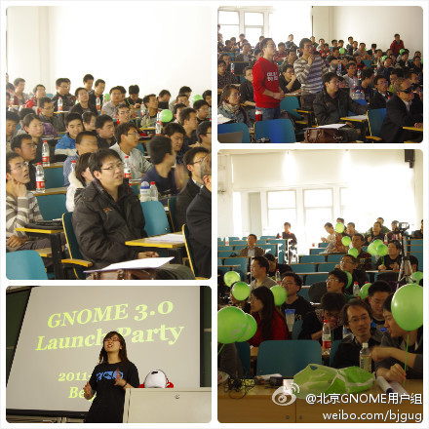

Key Event List

2013 | Events
Sept 21 | SFD(in schduling)
Aug 13 | Fedora 19 release party
May 06 | Ubuntu and UbuntuKylin13.04 release party
May 01 | GsoC sharing
Apr 27 | OpenSUSE 12.3 release party
Mar 19 | The unity of open source community(Fedora, Ubuntu and openSUSE)
Jan 27 | Fedora 18 release party
2012
Dec 15 | Touchpad's OS and Firefox OS
Sept 15 | Software Freedom Day 2012
Aug 01 | A Reunion with Taiwan GNOME User Group
May 19 | Opensource computing and OpenStack Salon
Apr 26 | openSUSE vs. Ubuntu in openStack
Mar 21 | GTK QQ, preexistence, this life and the future life
Feb 8 | A Reunion with BLUG(Beijing Linux User Group)
2011
Dec 21 | GNOME Localization and GNOME Appstore
Nov 19 | Ubuntu-tweak Introduction
Oct 20 | Mozilla Firefox 7 new features
Sept 15 | Software Freedom Day 2011
Aug 17 | Introduction of Embeded Linux
Jul 23 | Reunion with Openparty
Jun 15 | GNOME3 install-fest
May 10 | GNOME 3.0 demo and openSUSE 11.4
Apr 9 | GNOME 3.0 Launch Party
Jan 19 | Testopia and Fedora Test Events
2010
Dec 11 | Reunion with Beijing Flamenco Community
Nov 28 | BJGUG 2st Anniversary Party
Sept 18 | Software Freedom Day 2010
Aug 29 | BJGUG 22th meeting - Local community in GNOME and Linux
Jun 6 | BJGUG 20th meeting — Development of Meego
May 19 | BJGUG 19th meeting — Live USB
May 8 | Ubuntu 10.04 LTS Release Party
Apr 19 | BJGUG 18th meeting — Free talk
Mar 17 | BJGUG 17th meeting — GNOME Installfest
Feb 17 | BJGUG 16th meeting — «Chuan Night» with BLUG
Jan 25 | BJGUG 15th meeting — joint with OpenSolaris User Group
2009
Dec 8 | BJGUG 14th meeting — Experience in GNOME.Asia 2009
Nov 18 | BJGUG 1st Anniversary Party
Nov 10 | Open Source in Schools
Oct 21 | Reunion with Beijing Google User Group — Introduction Chromium and GSoC
Sept 16 | Gnome Developer Edition and General GNOME Environment
Aug 19 | GNOME3.0 firstlook and X-moto
Jul 15 | HBF from Windows to GNOME/Ubuntu
Jun 17 | Ccnet Project
May 20 | Reunion with BJOSUG, Unix-center Community and LXDE
Apr 15 | BJGUG 6th meeting — Google Gadgets
Mar 18 | BJGUG 5th meeting — sTeam and reading
Feb 18 | BJGUG 4th meeting — Moblin v2 and Faster Translation
Jan 14 | BJGUG 3rd meeting - GNOME + robot = Gnobo and Accessibility Localization Workshop
2008
Dec 17 | BJGUG 2nd meeting — Accessibility Introduction and Discussion Panel
Nov 26 | BJGUG 1st meeting — How to orgnizing the BJGUG

Proposed organizing committee
- Ms. Emily Chen, Oracle engineer, founder of BJGUG.
- Mr. Bin Li, president of BJGUG
- Mr. Born, vice-president of BJGUG
- Mr. ZhenNing Li, CS2c marketing manager
- Mr. TongHui, Contributer of open hardware
- Mr. JunYi Tang, MeiTuan engineer
- Mr. Christopher Meng, Fedora ambassador
- Mr. WenZhe Chui, CS2C engineer
- Mr. Arong Xu, Canonical engineer
- Ms. Elly Liu, Wistron Localization manager
- Mr. BootingMan, ChongQing LUG orgnizer.
- Mr. Wei Du, SUSE QA engineer
- Ms. Sunny Sun, SUSE RD Manager
- Mr. David Liang, SUSE Desktop Manager
- Mr. ChangJun Hu, China OSS Promotion Union
- Mr. Alick Zhao, Fedora ambassador
- Mr./Ms. ...

Proposed supporting organisations
- Beijing Linux User Group(BLUG) (http://blug.chinalug.org/)
- ChinaUnix (http://www.chinaunix.net/)
- QingHua University.

3. Objectives
Conference
- To attract more GNOME contributors, users and developers.
- To celebrate the latest GNOME release and create talking points to the press.
- To make use of this big event to promote GNOME in different Asian countries

Hackfest

- To provide a place for the GNOME hackers and discuss ideas face to face.
- To provide a launch party for beginners

Party/Sports
- To provide a party so that have a comfortable environment for communicating
- To provide a sport so that we could have a good team-work.

4. Venue & date

Tentative dates
Three possible periods: Jun 27-30 in 2014
Pre-event: Jun 27 (Friday)
Conference: Jun 28(staturday), Jun 29 (Sunday)
Hackfest: Jun 30(Monday)

Suggested Venue

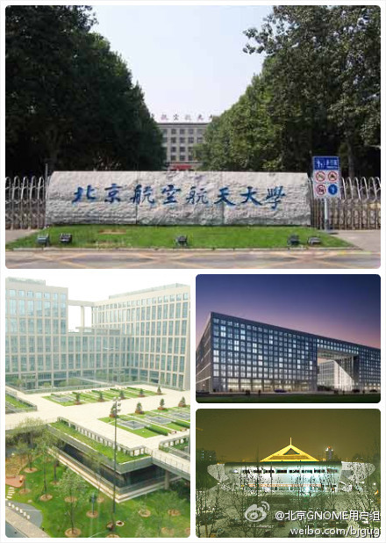
College Software of BeiHang University

Environment of BeiHang University
The dean of this college is our friend, so maybe we could have some venue in cheaper price, and if we have good luck, maybe for free.
Address: BeiHang University, No.37 XueYuan Lu, HaiDian District, Beijing.
Currently we still can't got the picture by ourselves, we could use classroom(~30p) as the hacking room, and there are a big hall looks like below, it's about 300 seats, which is could be used as our proposed venue.
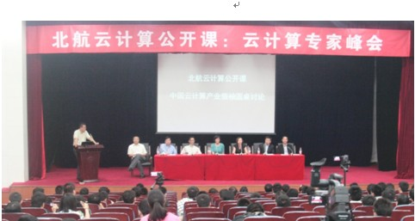
BeiHang University Hall

University of Chinese Academy of Sciences
This is the another choice for the Venue.
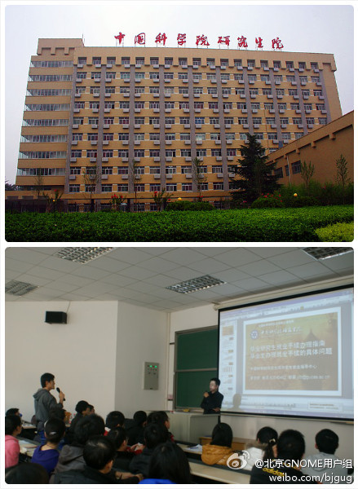

Address: No.80 ZhongGuanChunDongLu, HaiDian District, Beijing.
We had an GNOME3.0 Launch Parth at in 2011, and there are a big classroom looks like above photo, it's about 200 seats, which is could be used as our proposed venue, there are also some smaller room(~30 seats) for hackfest can be used for free.

QingHua University
QingHua University is the No.1 in Beijing and China, it's very famous, in recent event we cooperate with QingHua several times, so I thought it should be an option for our venue.

The FIT build in QingHua have a lot of classroom and meeting room, but unfortunly I still can't get the picture of it now.
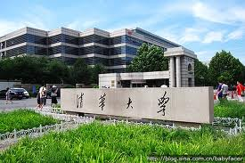

5. Target audiences
Hackfest (~ 15 GNOME contributors / developers):
- GNOME Shell Developers
- GNOME Localization Team
- GNOME Documentation Team
- GNOME contributors working on the GNOME 3.9 (or beyond)
Conference (200 - 300 people):
- Existing and potential GNOME contributors, users and developers
- University students

6. Activities and schedule

Hackfest
The hackfest will be similar to an unconference, a wiki page can be put up to allow participants to write down their proposed topics. The whole day event is free schedule. Activities include:
- BOF / Hacking
- Install-fest to help students install the GNOME Desktop
- Discussion

Public Conference
- Keynotes
- Talks
- Lightning Talks
- Booths ( exhibitions from 8:00 to 17:00)
- Party after the conference
Schedule
 | Hall(Day 1) | Hall(Day 2)
09:00 | Party starts
09:10 | Welcome speech - Local organizer & GNOME.Asia Committee
9:30 | Keynote #1 - the latest GNOME | Keynote #3
10:30 | Keynote #2 - The GNOME Foundation | Keynote #4
11:30 | Talk #1 | Talk #6
12:20 | Lunch Break
14:00 | Talk #2 | Talk #7
14:40 | Talk #3 | Talk #8
15:20 | Talk #4 | Talk #9
16:00 | Talk #5 | Talk #10
16:40 | Lightning talks | Lightning talks
17:40 | Lighting talks | Closing speech, Local organizer & GNOME.Asia Committee
18:00 | Take a bus to go to the dinner party

Party / Sports
We try to find some sponsor for the party or sports.

Optional: 1 day local tour
We could provide several choice for 1 day city tour, such as Temple of Heaven, Bird Nest, Greatwall, etc.

7. Expectation and marketing
We will send out "call for participation" 2 months before the event. We expect to have around 15 people joining the Hackfest while around 200 participants joining the conference.
Please find below the communication channels:

Hackfest
- GNOME.org website
- Selected mailing lists from GNOME and other related communities
- Selected IRC channels from GNOME and other related communities
- GNOME developers from different companies e.g. SUSE, Red Hat, Oracle, Canonical, ...
- Blog posting @ PlanetGNOME and other planets
- Invitations to selected GNOME contributors
- Social Networks e.g. Twitter, Weibo

Conference
We intend to invite participants from China and other Asian countries to attend the conference. On top of the above marketing channels, mass scale marketing will also be carried out 2 months before the conference in Beijing and other Asian countries.
- Advertising in the universities, IT related colleges and some secondary schools in Beijing.
- Articles and/or website banners at all FOSS communities and distros in Beijing
- Mailing list of GNOME.Asia@gnome.org, every FOSS communities and distros that use GNOME
- Word of mouth
- Social Networks e.g. Weibo, Twitter, BBS

8. Budget Estimation

Maximum Budget
Category | description | Qty | U/P (USD) | Amount (USD)
Conference Venue | BeiHang University, 1 hall (~200 people) and Exhibition area | 2days | 400 | 800
Conference meals | Lunch coupon in university canteen(optional) | 200 | 4 | 800
Conference coffee | Coffee and cookies from university | 200 | 2 | 400
Transportation | Shuttle bus for hackers / supporters / volunteers party | 2 | 50 | 100
Marketing materials | Tshirts | 200 | 9 | 1800
Marketing materials | Stands  - 4 for Hackfest,  - 4 for conference schedules,  - 6 for conference | 14 | 18 | 252
Marketing materials | Banner | 1 | 1 | 50
Marketing materials | Conference flyers  (with schedule) | 200 | 0.5 | 100
Marketing materials | Posters | 20 | 5 | 100
Optional tour | 1 day tour | 10 | 30 | 300
Sub-total |  |  |  | 4702
Travel subsidy | Average amount according to the pre-event survey | 15 people | 1,000 | 15,000
Accommodation | standard room for 2 person shared | 5days x 15people | 50 | 3750
Miscellaneous (10%) |  |  |  | 2345.2
Grant-Total |  |  |  | 25797.2
Highlights:
1) Every item is subject to 10% Miscellaneous Fee just in case to cover some unexpected expenses
2) The budget also could ignore the meals and transportation, it's very cheaper in Beijing, and generally the paticipants cover it by themselves, so at the minimum budget these are ignored.

Minimum Budget

Category | description | Qty | U/P (USD) | Amount (USD)
Conference Venue | BeiHang University, 1 hall (~200 people) and Exhibition area | 2days | Free | 0
Conference coffee | Coffee and cookies from university | 200 | 2 | 400
Marketing materials | Tshirts | 200 | 9 | 1800
Marketing materials | Stands  - 4 for Hackfest,  - 4 for conference schedules,  - 6 for conference | 14 | 18 | 252
Marketing materials | Banner | 1 | 1 | 50
Marketing materials | Conference flyers  (with schedule) | 200 | 0.5 | 100
Marketing materials | Posters | 20 | 5 | 100
Sub-total |  |  |  | 2702
Travel subsidy | Average amount according to the pre-event survey | 15 people | 800 | 12,000
Accommodation | standard room for 2 person shared | 5days x 15people | 30 | 2250
Miscellaneous (10%) |  |  |  | 1695.2
Grant-Total |  |  |  | 18647.2

9. Potential sponsors & media partners
Our members had contact with different company, community and university, and also we will help to send out "call for sponsors" to find local sponsors in Beijing.
Potential Sponsors
- SUSE, Joint with openSUSE Conference in Beijing still discussing
- Canonical
- Oracle
- Red Hat
- Intel
- cs2c (http://www.cs2c.com.cn/)
- China OSS Promotion Union(http://www.copu.org.cn/)
- Wistron(http://www.wistronits.com/)
- ChinaUnix (http://www.chinaunix.net/)
- Others
Potential Media Partners
- Linux Sir (http://www.linuxsir.org/)
- ChinaUnix (http://www.chinaunix.net/)
- CSDN (http://www.csdn.net/)
- 51CTO (http://www.51cto.com/)
- Others

10. Conclusion
BJGUG have a great team of passionate people and plenty of experience in hosting events and conferences. We have been talking to different local FOSS communities and potential sponsors as well as media partners about this proposal, all of them showed their supports to this GNOME event. We strongly believe Beijing is the best place to host this upcoming conference and hackfest. If you have any questions, please feel free to contact us. Thank you.

