
Proposal of GNOME.Asia Summit 2012
/ GNOME Conference & Hackfest
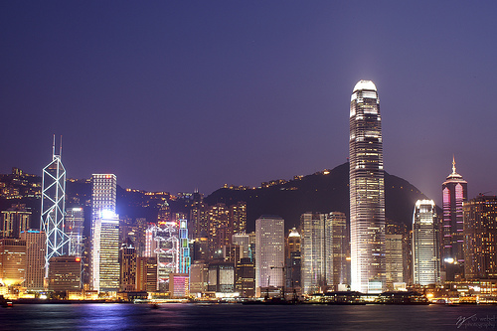
Proposed city: Hong Kong
Proposal by: DotAsia Organization / OAKA Hong Kong
Proposed date: Jan 28-Feb 3, Feb 4-10 & March 3-9 in 2012
Contact person: Edmon Chung <edmon@registry.asia>
Haggen So <haggenso@gmail.com>

Table of Contents
- Executive summary
- Local organizers and supporters
  - DotAsia
  - OAKA
  - Proposed organizing committee for Summit, Hackfest & Launch
  - Proposed supporting organizations
- Objectives
- Theme
- Venue and date
  - Tentative dates
  - Suggested hackvest venue
  - Suggested conference venue
- Target audiences
  - Hackfest
  - Conference
- Activities and schedule
  - Hackfest
  - Conference
  - Optional Local tour
- Expectations and marketing
  - Hackfest
  - Conference
- Budget estimation
- Sponsors and media partners
  - Potential sponsors
  - Potential media partners
- Conclusion

1. Executive Summary
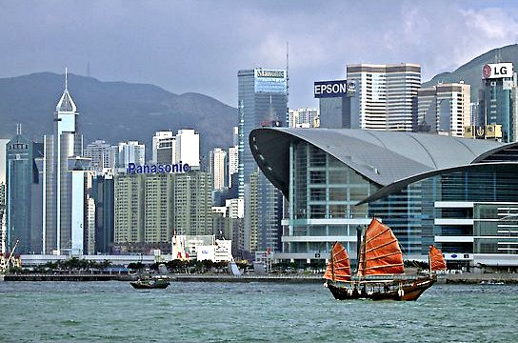
The DotAsia & OAKA team proposed to the GNOME.Asia Committee and The GNOME Foundation that the upcoming GNOME.Asia Summit 2012 / GNOME Hackfest to be hosted in Hong Kong. The tentative dates of the event will be around the GNOME 3.4 release. Hong Kong is well known being one of the largest cities in southeast Asia, with a thriving cultural scene, solid infrastructure, robust public transportation system and top notch eats. Hong Kong is also well known as shoppers and food paradise Besides, many countries have a visa-free period for travel within Hong Kong. We strongly believe Hong Kong is the best place to host this upcoming conference and hackfest.

2. Local Organizers and Supporters

DotAsia Organisation
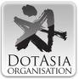
DotAsia Organisation is a not-for-profit organization incorporated in Hong Kong. It is the Sponsoring Organisation and Registry Operator for the .Asia Sponsored Generic Top Level Domain (TLD). DotAsia oversees the policies and governance of the “.Asia” TLD Registry.
The DotAsia Organisation is established with a mandate to contribute its proceeds into socio-technological advancement initiatives for the Internet community in Asia. Leveraging the network and expertise at DotAsia, community contributions will be directed towards the following 3 main areas:
- Digital inclusion related projects, especially in the bridging the digital divide and helping the digital “have-nots” gain better access to information technology
- Initiatives advancing education in Asia as well as scholarships and other open knowledge contributions (such as open license educational materials), especially leveraging the Internet
- Research and development efforts that are charitable nature and beneficial to the community, including projects such as socio-technical research, open source development, disaster relief and rebuild efforts especially on information infrastructure support, etc.
Ongoing projects and involvements:
- www.olpc.asia
- www.creativecommons.asia
- www.netmission.asia
- www.paragon100.asia
- www.asianfilmawards.asia
- hk.dsf.asia
- www.isif.asia
- www.relief.asia
- www.rigf.asia
- www.blogfest.asia
- www.ipv6world.asia

OAKA
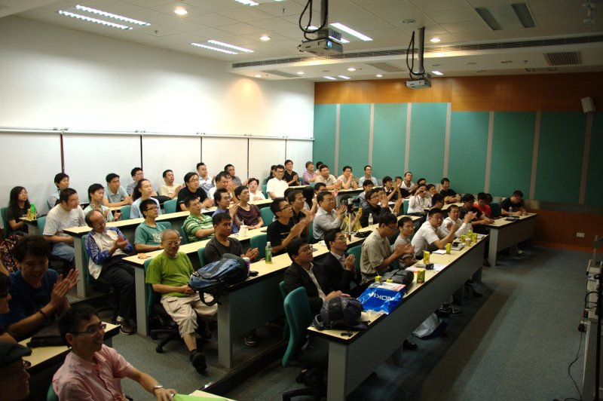

Opensource Application Knowledge Association, OAKA is a not for profit opensource organisation based in Hong Kong. OAKA is established and registered under HK Societies Ordinance in 2004 by a group of Free and Opensource advocates with different professions. OAKA is aimed to study how to apply opensource software and concepts in practice, and promote Free and Opensource applications to general public. OAKA is the most active grass-root opensource event organiser in Hong Kong.
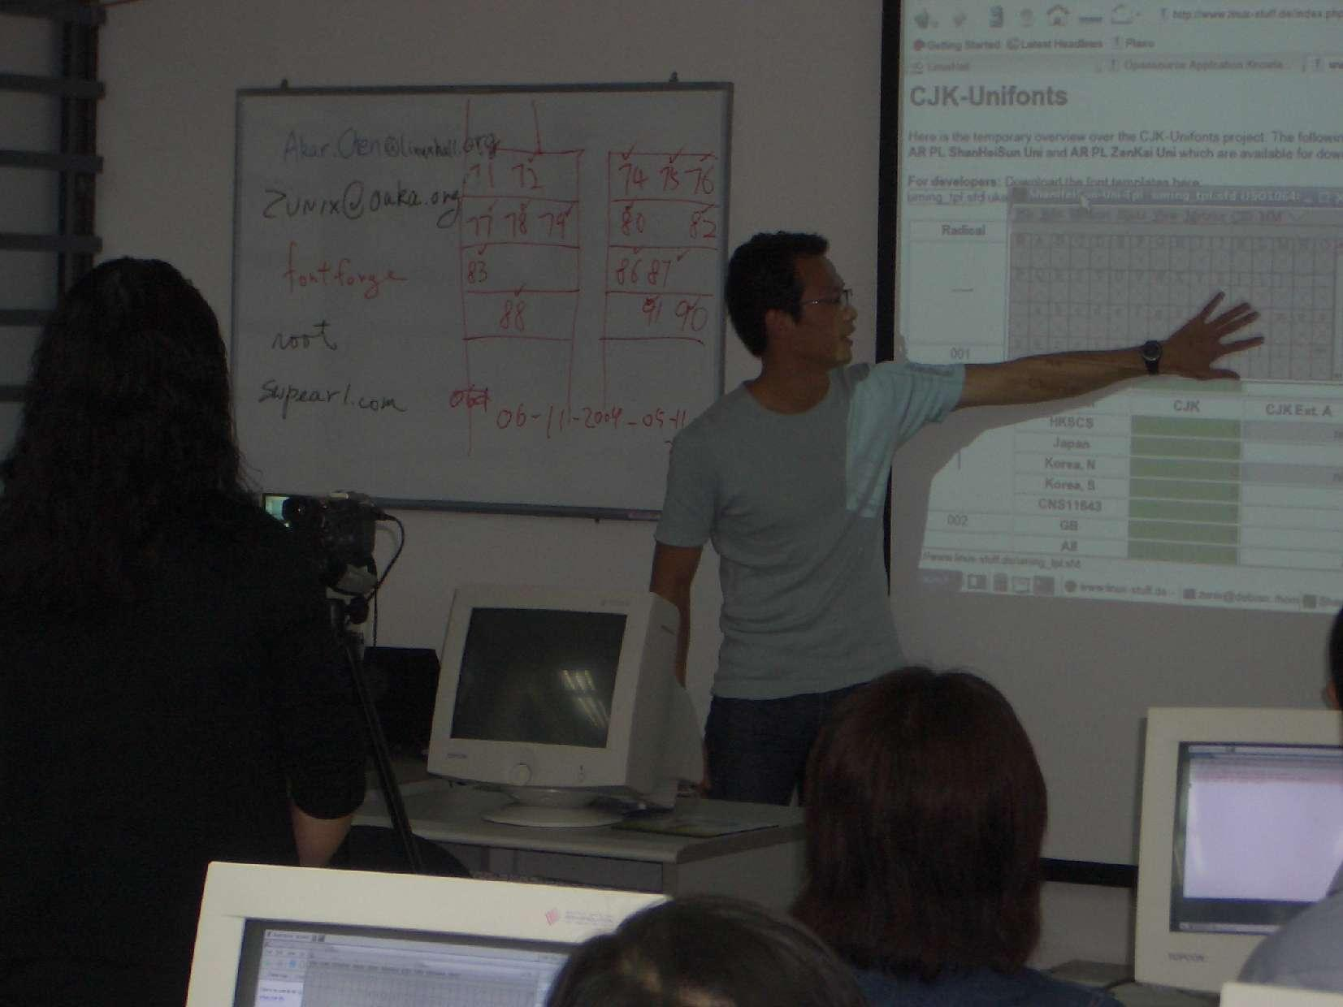
Chinese FreeFonts project is a Chinese font making project to create 4,700+ Chinese characters commonly used in Hong Kong, released in open source license. Fonts are merged with existing opensource traditional & simplified Chinese fonts. 12 Chinese FreeFont Making Workshops are organised by OAKA for this project.
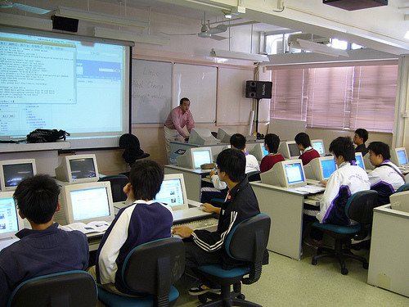
Teamed up with the Hong Kong Federation of Education Workers, OAKA pioneered the OSFarm and OSLeader Project in 2005-07 funded by the Quality Education Fund from the government.
- Created a localised Linux CD for Schools and Distributed about 1000 Physical Copies.
- Reached out to more than 30 schools, Trained more than 90 Students as OSLeader and each of them helped 3 other students to adopt FOSS.
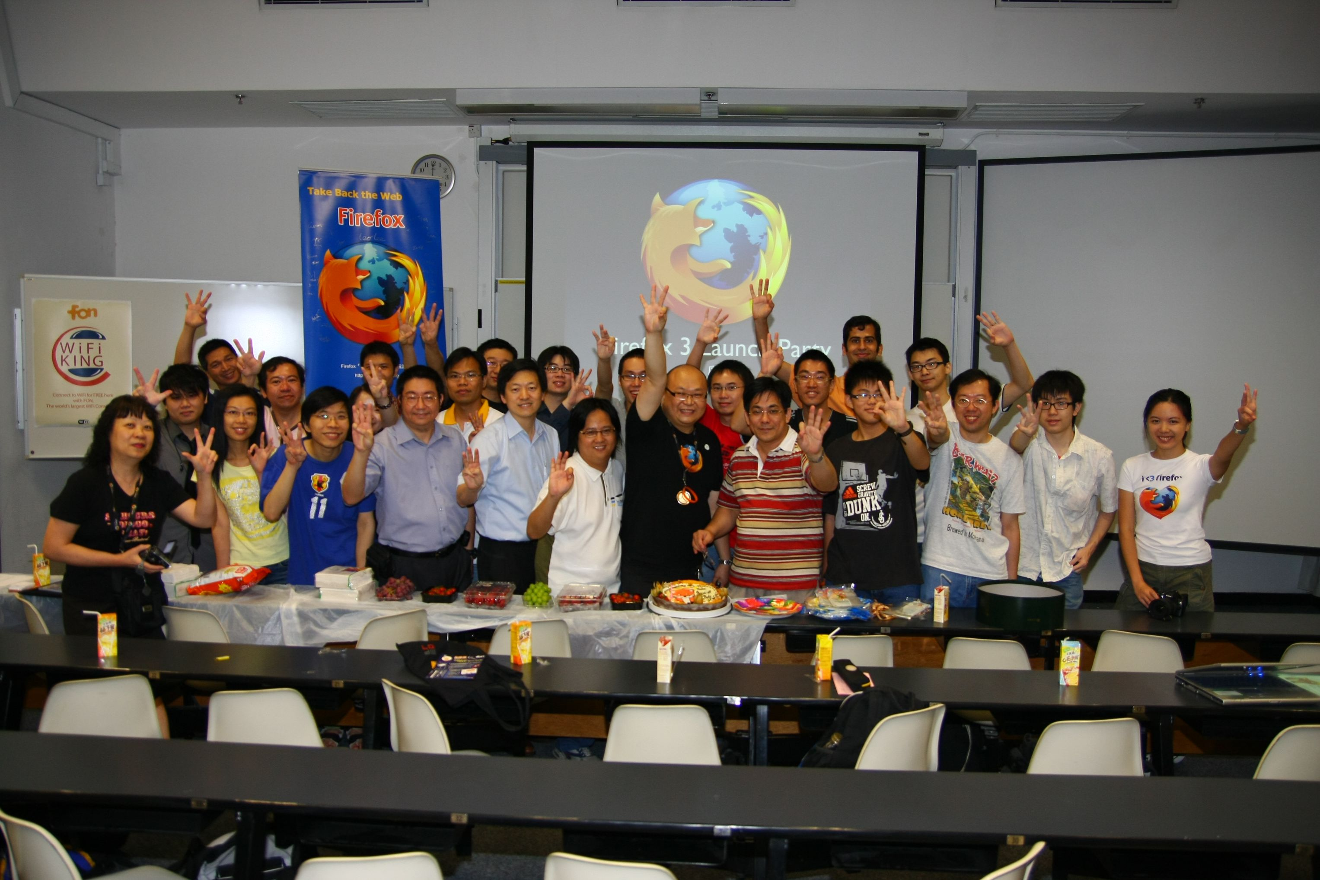
OAKA organised Firefox Parties in 2004, 2008 and 2011 for version 1.0, 3.0 and 4.0, targeted hundreds of local Firefox users.
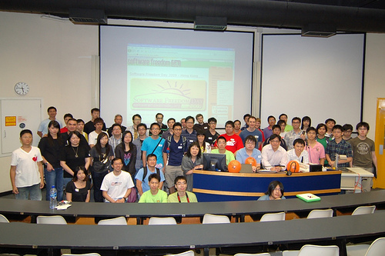
Software Freedom Day in 2009 and 2010, organised by OAKA, have more than 150 audiences.
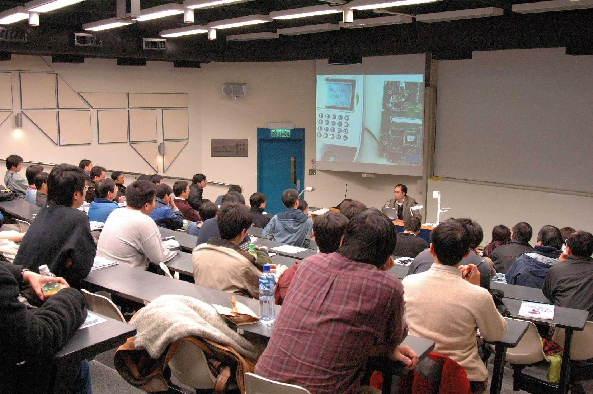
OAKA organises Ad-hoc gatherings for different F/OSS-related topics in different scales. Examples: Mobile The Gathering, Maemo Development and MeeGo, Ubuntu 10.10 Release Party, Netbook The Gathering, EeePC The Gathering, Linux The Gathering.
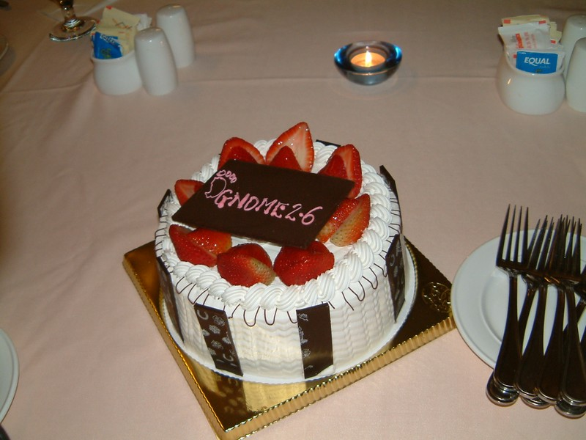
And we celebrated GNOME 2.6 Release in Hong Kong too.

Key Event List
May 14, 2011 - Firefox 4 Launch Party
Apr 09, 2011 - GNOME 3.0 Release Party, Hong Kong
Dec 04, 2010 - Education and Open Source
Nov 25, 2010 - Meego Casual Meetup
Nov 06, 2010 - Mobile The Gathering
Oct 17, 2010 - Ubuntu 10.10 Release Party Hong Kong
Sep 18, 2010 - Software Freedom Day @ BarCampHK 2010
Jul 13, 2010 - Maemo Development and MeeGo
Sep 19, 2009 - Software Freedom Day 2009 Hong Kong
Mar 25, 2009 - Document Freedom Day Meetup, Hong Kong
Jan 10, 2009 - Introduction of OLPC project
Nov 29, 2008 - Netbook The Gathering
Aug 16, 2008 - Debian Birthday Party, Hong Kong
Jun 28, 2008 - Firefox 3 Party
Feb 02, 2008 - EeePC The Gathering
Oct 27, 2008 - Linux The Gathering #3
Aug 25, 2008 - Linux The Gathering #2
Jul 3-5, 2007 - OSLeader Sharing & Competition Camp
Jun 30, 2008 - Linux The Gathering #1
Jun 09, 2007 - DIY Embedded Linux System
May 12, 2007 - Chinese FreeFonts Project Seminiar: Problem and Solution of Chinese Fonts on Computing
May 1-Jun 30, 2007 - OSLeader Community Services in 20 Local Schools
Mar 10, 2007 - Asterisk PBX & VoIP Seminiar
Dec 27, 2006-Feb 27, 2007 - OSLeader training in Kwun Tong, Hong Kong Island, Tuen Mun & Shatin
Aug 26, 2006 - Linux Cafe
Jul 07, 2006 - OGCIO OpenOffice Seminiar
Jun 28, 2006 - OpenOffice Seminiar
Jun 10, 2006 - Annual General Meeting, OAKA.
Jul 24, 2005 - Fedora Core 4 Laptop Meetup
May 15, 2005 - Opensource Chinese Freefonts Workshop #12
May 08, 2005 - LiveCD Creation Workshop
Mar 13, 2005 - Linux Laptop Party
Mar 12, 2005 - Linux Server Administration Seminiar
Nov 21, 2004 - Firefox 1.0 Party, Hong Kong
Nov 14, 2004 - Opensource Chinese Freefonts Workshop #01
Oct 17, 2004 - Linux Chinese Desktop Installation Workshop
Proposed organizing committee for Summit, Hackfest & Launch
- Mr. Edmon Chung, CEO, DotAsia
- Mr. Charles Mok, Internet Society
- Mr. Kelvin Truong, DotAsia
- Ms. Ping Wong, DotAsia
- Dr. Haggen So, Vice-President, OAKA
- Mr. Sammy Fung.
- Mr. K.S. Chan
- Mr. Steven Mak
- Mr. Henry Law
- Ms. Amanda Lam
Proposed supporting organisations
- Hong Kong Internet Society (http://www.isoc.hk/)
- City University of Hong Kong (http://www.cityu.edu.hk/)
- Breakthrough (http://www.breakthrough.org.hk/index)
- BarCamp Hong Kong (http://barcamp.org/w/page/400816/BarCampHongKong)
- Wikimedia Foundation Hong Kong (http://wikimediafoundation.org/)
- Ubuntu Hong Kong Loco Team (http://loco.ubuntu.com/teams/hongkonglocoteam)
- Creative Commons Hong Kong (http://hk.creativecommons.org/)
- Hong Kong Embedded Linux Interest Group
- Hong Kong Linux Industry Association (http://www.hklia.org/)
- Debian Hong Kong (http://www.debian.org.hk/)
- Hong Kong Linux User Group (http://wiki.linux.org.hk/)
- Hong Kong Open Source Software Centre, Hong Kong Productivity Council (http://coe.hkpc.org/html/eng/centres_of_excellence/hkossc/index.jsp)
- IVE Hong Kong (http://www.vtc.edu.hk/)
- Department of Computing Science, Hong Kong University
- Hong Kong Science Park (http://www.hkstp.org)
- Cyberport (http://www.cyberport.hk)
- OGCIO, Hong Kong Government (http://www.ogcio.gov.hk/)

3. Objectives
Hackfest
- To provide a place for the GNOME release team, marketing team and documentation team to work on GNOME 3.4 (or beyond) together
- To make sure that the release is successful and nothing is missing
Conference
- To promote the GNOME 3.4 release in local area and attract more GNOME contributors and users
- To celebrate the GNOME 3.4 release and create talking points to the press
- To make use of this big event to promote GNOME in different Asian countries

4. Theme
Suggestions
- Celebrate the GNOME 3.4 launch
- GNOME 3.4 - Made of Easy
- GNOME 3.4 - Fundamentally Different

5. Venue and date

Tentative dates
Three possible periods: Jan 28-Feb 3, Feb 4-10 & March 3-9 in 2012
Conference: First two days of one of the above periods
Hackfest: Last five days of one of the above periods

Suggested Hackfest Venue

Breakthrough Youth Village Campsite
Address: Breakthrough Youth Village, 33 A Kung Kok Shan Road, Shatin, The New Territories, Hong Kong
Special offer for non-profit organization: ~US$ 44 / person / day (HK$340)
- Simple bed-room (2 persons / room)
- Meals
- Coffee
- General purpose room with Internet access
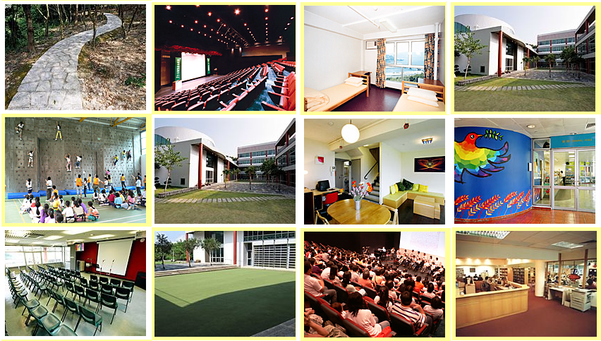
Photo 1: Pictures of different corners of the Breakthrough Village
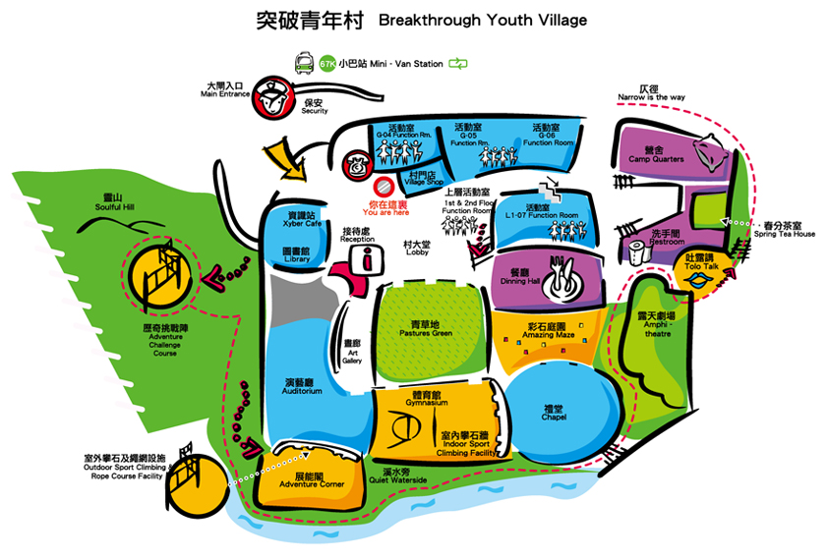
Photo 2: Floor plan of the whole Breakthrough Village

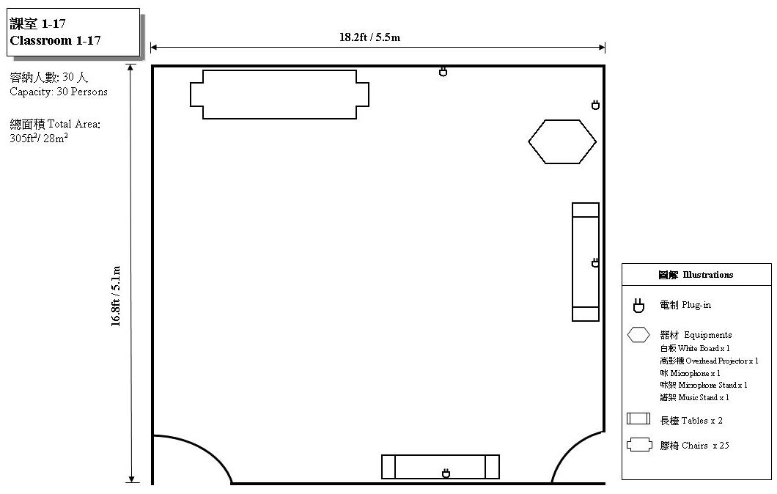
Photo 3: Activity Room for 30 people provided by Breakthrough
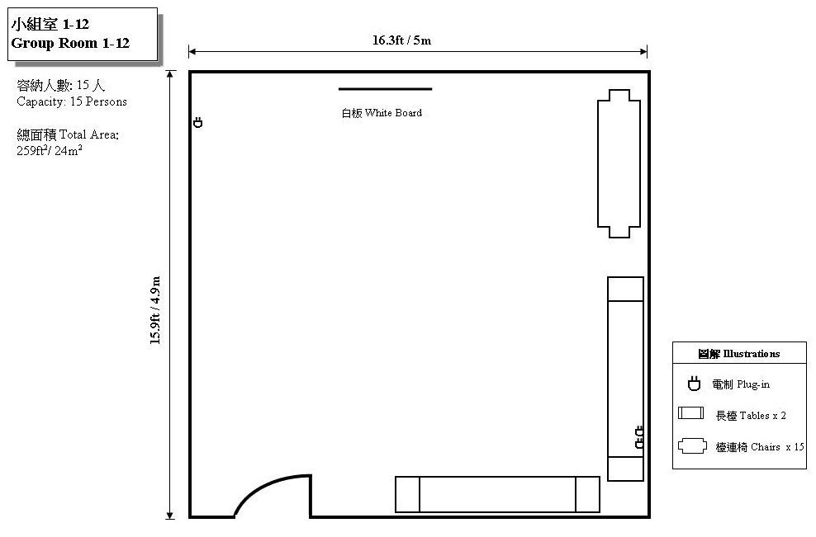
Photo 4: Activity Room for 15 people provided by Breakthrough
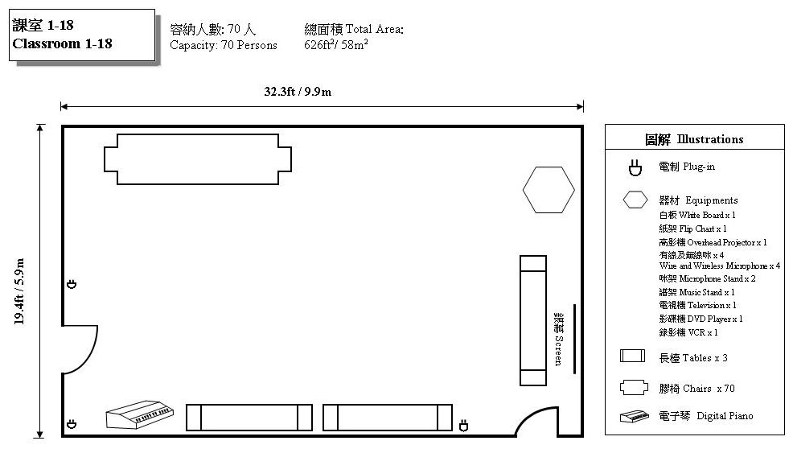
Photo 5: Activity room for 70 people provided by Breakthrough

Suggested conference venue

City University of Hong Kong
Address: City University of Hong Kong Tat Chee Avenue Kowloon Hong Kong (next to Kowloon Tong MTR Station)
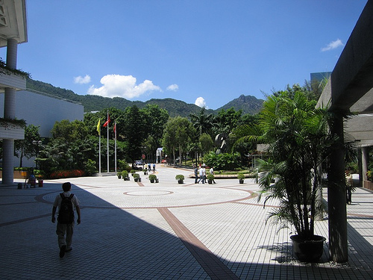
Photo 6: Environment of City University

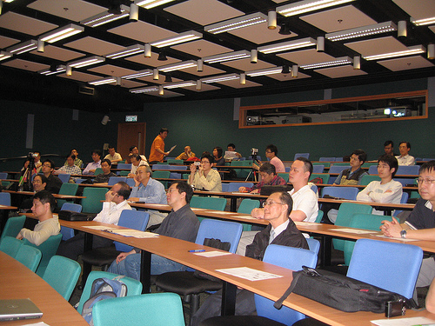
Photo 7: City University smaller size hall (100- proposed venue for track 2
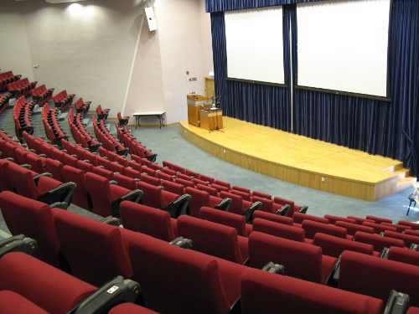
Photo 8: City University LT401 Hall (300 seats) - proposed venue for keynotes (track 1)

6. Target audiences
Hackfest (~ 15 GNOME contributors / developers):
- GNOME Shell Developers
- GNOME Marketing Team
- GNOME Release Team
- GNOME Documentation Team
- GNOME contributors working on the GNOME 3.4 (or beyond)
Conference (200 - 300 people):
- Existing and potential GNOME contributors and users
- They are developers and university students

7. Activities and schedule

Private Hackfest:
The private hackfest will be similar to an unconference, a wiki page can be put up to allow participants to write down their proposed works / topics. Activities include:
- Getting things done
- Hacking
- Collaboration
- Discussion
- Technical helpdesk
* Whole day event - free schedule
Public Conference:
- Keynotes
- Talks
- BOF
- Lightning Talks
- Booths
- Party after the conference
P U B L I C C O N F E R E N C E S C H E D U L E
 | Track 1 | Track 2
08:00 | Party starts
08:45 | Welcome speech - Local organizer & GNOME.Asia Committee
9:00 | Keynote #1 - GNOME 3.4
10:00 | Keynote #2 - The GNOME Foundation
11:00 | Keynote #3 - Platium Sponsor
12:00 | Lunch
13:30 | Talk #1 | Talk #2
14:00 | Talk #3 | Talk #4
14:30 | Talk #5 | Talk #6
15:00 | Talk #7 | Talk #8
15:30 | Talk #9 | Talk #10
16:00 | Talk #11 | Talk #12
16:30 | Talk #13 | Talk #14
17:00 | Lightning talks | Lightning talks
17:30 | Closing speech - Local organizer & GNOME.Asia Committee
18:00 | Take a bus to go to the dinner party
* There will be booths and exhibitions from 8:00 to 17:00
* We proposed to have a party room (and support booth) as well, the purpose is to help students / participants to install GNOME Shell and Linux Desktop with GNOME 3.4. We can also prepare some GNOME related games in the party room.

Optional: 1 day local tour
A travel agency with English speaking tour guide can be hired to take care of the 1 day tour.
Option 1: 1 Day Best Hong Kong Tour of Peak Tram - Victoria Peak - Repulse Bay

Option 2: 1 Day Extension Tour of Hong Kong Convention Exhibition Center - Huangdaxian Memorial Temple
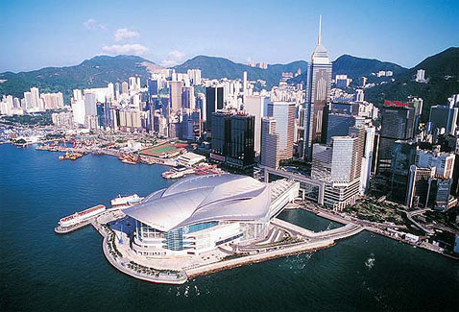
Option 3: 1 Relaxing Day of Temple Visit in Lantau Island


8. Expectation and marketing
We will send out "call for participation" 2 months before the event. We expect to have around 15 people joining the Hackfest while around 300 participants joining the conference.
Please find below the communication channels:
Hackfest:
- GNOME.org website
- Selected mailing lists from GNOME and other related communities
- Selected IRC channels from GNOME and other related communities
- GNOME developers from different companies e.g. Red Hat, Novell, Oracle
- Blog posting @ PlanetGNOME and other planets
- Invitations to selected GNOME contributors
- Social Networks e.g. Facebook, Identi.ca, Status.net, Twitter, Linkedin

Conference:
We intend to invite participants from Hong Kong and other Asian countries to attend the conference. On top of the above marketing channels, mass scale marketing will also be carried out 2 months before the conference in Hong Kong and other Asian countries.
- Advertising in 8 universities, IT related colleges and some secondary schools in Hong Kong
- Articles and/or website banners at all FOSS communities and distros in Hong Kong
- Mailing list of GNOME.Asia@gnome.org, every FOSS communities and distros that use GNOME
- Magazine / newspapers ads
- News site banners and articles
- Word of mouth
- Social Networks e.g. Facebook, Identi.ca, Status.net, Twitter, Linkedin

9. Budget Estimation
Maximum Budget
Category | Item and description | Qty | U/P (USD) | Amount (USD)
Hackfest Venue, coffee and lunch / Dinners | Breakthrough village: including accommodation, meals and a general purpose room with internet access  2 persons / room (USD 44 / person)  (enjoy non-profit organization discount) | 5 days x 15 people# | 44 | 3,300
Conference Venue | City University of Hong Kong | 1 hall (300 people)  1 hall (100 people)  Exhibition area | Free | Free
Conference meals | Lunch coupon in university canteen | 300 | 4 | 1,200
Conference coffee | Coffee and cookies from university | 300 | 2 | 600
Transportation | Shuttle bus for hackers / supporters / volunteers party | 15 | 3 | 45
Volunteer party | Boat trip dinner to visit night view of HK | 15 | 30 | 450
Marketing materials | Tshirts | 300 | 3 | 900
 | Stands  - 4 for Hackfest,  - 4 for conference schedules,  - 6 for conference | 14 | 18 | 252
 | Banner | 1 | 1 | 45
 | Conference flyers  (with schedule) | 300 | 0.5 | 150
 | Posters | 20 | 4.5 | 90
Optional tour | 1 day tour | 10 | 65 | 650
Sub-total |  |  |  | 7,682
Travel subsidy | Average amount according to the pre-event survey* | 12 people | 1,000 | 12,000
Miscellaneous (10%) |  |  |  | 1,868.20
Grant-Total |  |  |  | 21,650.20
# We may also consider to rent the rooms 1 or 2 more days
* With the assumption that 50% of the respondents requesting subsidy asked for the max. range amount and the other 50% half of the amount
Minimum Budget
Category | Item and description | Qty | U/P (USD) | Amount (USD)
Hackfest Venue, coffee and lunch / Dinners | Breakthrough village: including accommodation, meals and a general purpose room with internet access  2 persons / room (USD 44 / person)  (enjoy non-profit organization discount) | 5 days x 15 people# | 44 | 3,300
Conference Venue | City University of Hong Kong | 1 hall (300 people)  1 hall (100 people)  Exhibition area | Free | Free
Conference meals | Lunch coupon in university canteen | 300 | 4 | 1,200
Conference coffee | Coffee and cookies from university
Transportation | Shuttle bus for hackers / supporters / volunteers party | 15 | 3 | 45
Volunteer party | Boat trip dinner to visit night view of HK | 15 | 30 | 450
Marketing materials | Tshirts
 | Stands  - 4 for Hackfest,  - 4 for conference schedules,  - 6 for conference | 14 | 18 | 252
 | Banner | 1 | 1 | 45
 | Conference flyers  (with schedule) | 300 | 0.5 | 150
 | Posters | 20 | 4.5 | 90
Optional tour | 1 day tour
Sub-total |  |  |  | 5,532
Travel subsidy | Average amount according to the pre-event survey* | 12 people | 1000 | 1,200
Miscellaneous (10%) |  |  |  | 1,753.20
Grant-Total |  |  |  | 19,285.20

10. Potential sponsor and media partners
We will help to send out "call for sponsors" to find local sponsors in Hong Kong.
Potential Sponsors
- dotAsia
- Cwlinux
- Oracle
- Red Hat
- Intel
- Others
Potential Media Partners
- Linux Pilot
- CSDN
- InfoQ
- 51CTO

11. Conclusion
DotAsia & OAKA have a great team of passionate people and plenty of experience in hosting events and conferences. Since being contacted in late August by the GNOME.Asia Committee, we have been talking to different local FOSS communities and potential sponsors as well as media partners about this proposal, all of them showed their supports to this GNOME event. We strongly believe Hong Kong is the best place to host this upcoming conference and hackfest. If you have any questions, please feel free to contact us. Thank you.

